Risk Map
Impact ↓ / Likelihood → | High | Medium | Low
High |  | R5, R2, R1 | R8
Medium |  | R6, R3 | R7, R4
Low

Risk ID Key
- R1: Model overfitting
- R2: Poor Grad-CAM focus
- R3: Dataset bias
- R4: Limited resources
- R5: Time constraints
- R6: Uneven workload
- R7: Integration issues
- R8: Over-claiming results
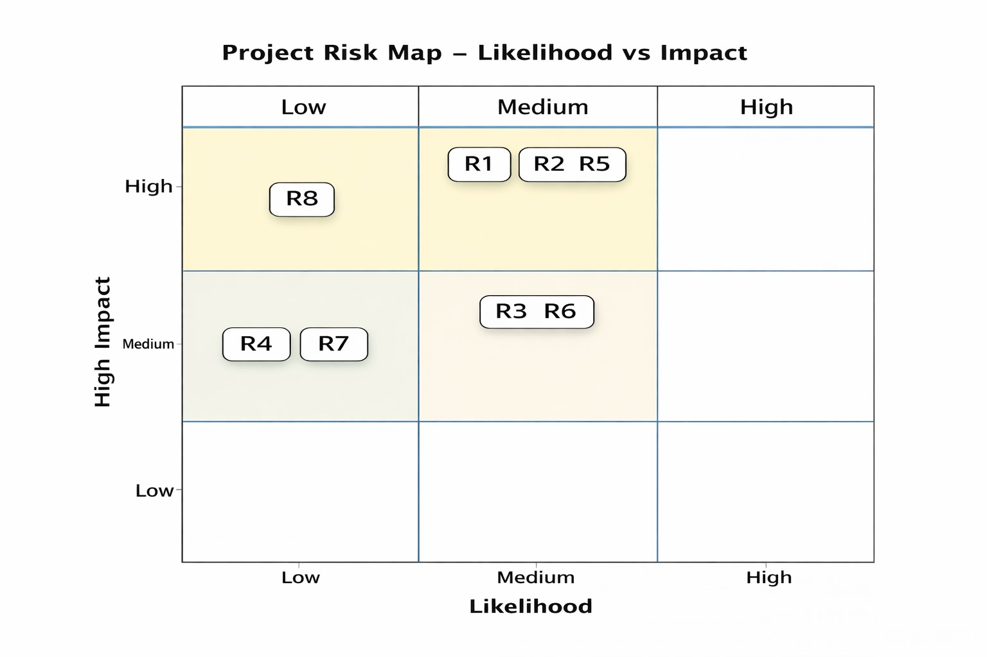
Figure 7 : Project Risk Map illustrating identified risks positioned according to their likelihood and impact.

Libre Project File
Google Drive Link :
https://drive.google.com/file/d/1I4WVxXdFKogHAHLW2cIoXpBz4ITppRLt/view?usp=sharing
https://drive.google.com/file/d/107rQ0D4d1vmoaG1qyBPh8rIh8wmDgLYF/view?usp=sharing

